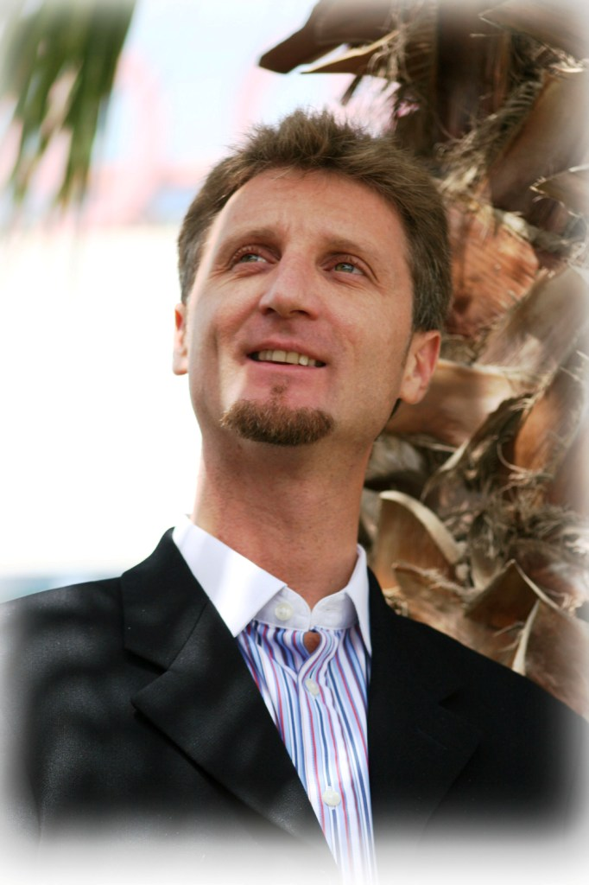
Kevin S Craig (CPCC, PCC, ORSC, FInstSMM)
PO Box 31699
Kingdom of Bahrain
 +973 36199980
kevin@craigconsultants.com
A C-level executive and team coach, and entrepreneurial businessman with exceptional outstanding abilities enabling both teams & individuals to maximise their full potential; an outstanding communicator able to develop knowledge, skill and facilitate behavioural and values based changes; within challenging global, multicultural competitive environments
at a strategic level to business.

Career Review

Faculty Leader, Executive & Team Coach – CTI GCC, Dubai, UAE March 2011 - Present
- Faculty member and Front of Room Leader
- Representative for Bahrain and Saudi Arabia

Faculty Leader – Coaches Training Institute (CTI) – San Rafael, California March 2011 - Present
- Faculty member and Front of Room Leader

CEO – Craig Consultants – Kingdom of Bahrain Sept 2008 – Present
- Representative and faculty leader for Coaches Training Institute (USA)
- International client base in Qatar, Kuwait, UAE, Saudi Arabia, UK, USA & Canada
- Sectors include: Logistics, Oil and Gas, Banking and Finance, Aviation, Manufacturing
- Over 85% repeat business
- Exceed clients expectations
- 60/40 Arab/Expat client mix
- Specialised in Executive and Organisational Coaching

Course Director (Part Time interest) – Professional Association Diving Instructors (PADI) International,
Bahrain & Saudi Arabia 1997 - Present
- >90% Continuing Education ratio
- Reputed for high quality and standards
- Educate up to Staff Instructor Level

Client Operations Managing Consultant (Bahrain, Saudi, Qatar & Kuwait) – Aconex, Bahrain May 2008 – Jan 2009
- Start-up company new to Middle East from Australia
- Building customer base & network – grow revenue by 60%
- Design Job & Competency development Matrix for business units
- Coach/Training users & staff – Create customer focused performance culture
- Strategy plan for region – Northern Gulf
- Recruited team & succession planning

Head Sales Training & Development – DHL Int’l, EEMEA Region – Bahrain July 2007 – May 2008
- Designed & implemented development matrix for all job roles
- Consultant & Coach to Country Managers & Area/Regional Directors
- Resource to Global organisation
- Built internal training organisation responsible for entire Commercial function
- Joint designer of 2008-10 strategic direction for Sales in EEMEA to enable extended growth
- Development of coaching culture
- Designed DHL International coaching programme
- Implementation of new e-learning platform

Head Sales Development for Middle East – DHL Int’l, Bahrain June 2004 – June 2007
- Internal Consultant & Coach to DHL Country Managers & Directors within Middle East
- Design & deployment of soft skills training
- Internal Coach to Sales Managers & Consultant resource for whole Emerging Markets region
- Implemented Commercial Development Strategy
- Designed Job Competency & Development matrix
- Aligned commercial procedures to today's business needs
- Developed Managerial Talent pool and structured succession planning for Commercial Managers
- Created Performance Culture with focus on “activity”
- Implemented “Best in Class” culture within commercial & Lead team of trainers
Head Organisational Development – DHL Int’l, Saudi Arabia Sept 2003 - June 2004
- Designed & Implemented Organisational Development Strategy
- Designed Job Competency & Development matrix
- Aligned HR policies to today's business needs
- Developed Managerial Talent pool and structured succession planning
- Internal Consultant & Coach to DHL Saudi and rest of Middle East at all level of the organisation
- Regional resource for whole Emerging Markets region
- Created a Performance Culture
- Initiated introduction of 360º Feedback
- Successfully designed Saudi Traineeship Programme for new Saudi National to achieve company Nationalisation targets
When prompted to this position I developed a strategic OD direction for the Business, expanding the team of operational and generalist trainers/consultants; responsible for all areas of development within DHL.
Training & Development Manager - DHL Saudi Arabia July 2002 - Sept 2003
- Designed & Delivered Management Development Programs across the Organisation
- Researched & Evaluated DHL's Business, leading to the Design and Delivery of a new Company Induction Programme and a raft of other courses
- Identified departmental development needs and sourced & delivered tailor made in-house courses
- Introduced and Managed first Performance Appraisal System to DHL Saudi
- Designed Cultural Orientation Programmes for new Expatriates
- Initiated Coaching at Junior & Middle Management Level
- Consultant to Heads of Business Units
Upon joining DHL in July 2002 there was no Training and Development function. I initiated and delivered numerous projects/initiatives creating a well-respected department, enabling individuals and the business to exceed its objectives.
Training & Project Manager - Siemens Communications Ltd. UK & Europe June 2001 - June 2002
- Implemented Change Management processes
- Implementation of e-learning platform
- Implemented Customer Service NVQ to 550 staff, increasing customer retention by 26% YOY
- Designed and implemented "Reward and Recognition" Strategy for the Customer Service Division
- Reduced ILT training days by 16% with use of blended learning models
- Developed Competency Matrix for Call Centre
Director of Training - Air Infotech, New Delhi, India July 2000 - May 2001
- Reduced attrition rate from 27% to 11.5% increased engagement & development of staff
- Commissioned new Training & Development centre
- Created & implemented Training & Development strategy
At that Air Infotech was the largest International outsourcing contact. I was responsible for all training and organisational development matters employing a large team of trainers and consultants. Using the services of the British Council and devising my own sales and cultural training to meet the needs of the client(s). I worked closely with the HR Department designing the recruitment processes. I also worked closely with Operations and deputised for the COO in her absence.
Regional Training Manager - Parity Training, UK Jan 2000 - July 2000
- Responsible for all training needs analysis of major clients
- Project managed role-out of Microsoft migration for major investment bank from conception thru execution
- Developed and designed courses
I joined Parity as an end-user trainer for the Microsoft Office range. Quickly establishing myself, I becoming regional trainer within a few months; responsible for key customers (BA, ING Barings, Nationwide) and their training requirements. I also became accredited by the Institute of IT Training after successfully passing the Institute's Trainer Delivery Skills course.
Sabbatical May 1999 - Jan 2000
- Pursued hobby of Scuba Diving and achieved PADI Staff Instructor status
- Conducted various Instructor Development courses
- Evaluated career and changed direction
I made a conscious decision to leave retail; to pursue my hobby of scuba diving in which I am a Staff Instructor and to evaluate my career. During this time I travelled to Egypt, Bermuda, Bahamas and USA.
Department Manager - John Lewis Partnership, UK Sept 1992 - May 1999
- Responsible for £1.2m budget
- Initiated and executed two projects increasing sales by 17% and net profit by 8%
- Set up pilot scheme of NVQ level 2 in Retailing, which resulted in roll-out through entire Group
- Role model department to "groom" future managers
Joining the Graduate Training Scheme I was soon promoted to Section Manager, and after various secondments promoted to Department Manager. During this time I also became increasingly involved in Training; designing and ran many Management Development programs. I did not limit myself to just Management training; I also ran sales, customer service, time management, and performance management courses.
Education
- Coaches Training Institute, San Rafael, California, USA
- Centre for Right Relationship, USA
- Kingston University, Kingston-upon-Thames, Surrey, UK
- Pierrepont School, Frensham, Farnham, Surrey, UK
- Clewborough House Preparatory School, Camberley, Surrey, UK
Qualifications
- CPCC – Certified Professional Co-Active Coach – Coaches Training Institute - USA
- Qualified ORSC (Organisational, Relationship & Systems Coaching) Coach
- Professional Certified Coach (PCC) - International Coaching Federation (ICF)
- Certificate in Coaching – Nottingham University
- Course Director – PADI – Professional Certification in Scuba Diving
- Emergency First Response Instructor Trainer
- NLP Master Practitioner Trainer
- NLP Master Coach Trainer
- NVQ Assessor - D32 & D33
Membership
- Entrepreneurs Organisation (EO) – Member, Bahrain Chapter
- Professional Certified Coach (PCC) - International Coaching Federation (ICF)
- Arabian Society for HR Management (ASHRAM) – Member
- Institute of Sales & Marketing Management – Fellow
- Bahrain Society for Training & Development - Full Member
- Bahrain Corporate Social Responsibility Society – Vice Chairman and Founding Member
- Manama Centre for Human Rights – Founding and Board Member
- Capital Club, Bahrain – Founding Member
- Bahrain HR Forum – Chairman and Co-Founder
- PADI - Professional Association of Diving Instructors
- Bahrain Debate Club – Founding Member
- NFNLP – Full Member
- Guards Polo Club - Member
Interests
- Scuba Diving, Sky Diving, Polo, Travel, Camping in the Desert, Reading & Learning.

